Our Youth will be attending the camp  We appreciate your donations where it is sending a team, being a hole sponsor, a tee box sponsor, give aways at the tournament, sponsoring an individual youth, or just your prayers.  To support please check:  Sponsoring a team ($400)  Sponsoring a hole ($250)  Sponsor a tee-box ($150)  Give away prizes  Sponsor a youth ($325)  Pray for our youth  Name _____________________________  Business ___________________________  Address ___________________________  Phone 903- _ _ _ - _ _ _ _  Check __ Cash__ Mail in___  CUAB, PO Box 833, Flint, Tx 75762 | 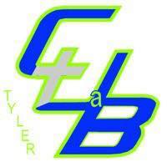  Event information  Cascades Country Club-April 8, 2019  Church Under a Bridge is sponsoring a golf tournament to assist our youth (12-18) in going on a mission trip and learning how to be an humble servant to others.  Approximately 20 youth will be traveling to Ruston, LA for the mission camp in June.  We treasure any support you are able to offer. Please note the information on the side panel for different ways to support our mission | Golf Tournament  Jerry “pops” whitaker memorial tournament  supports youth mission trip  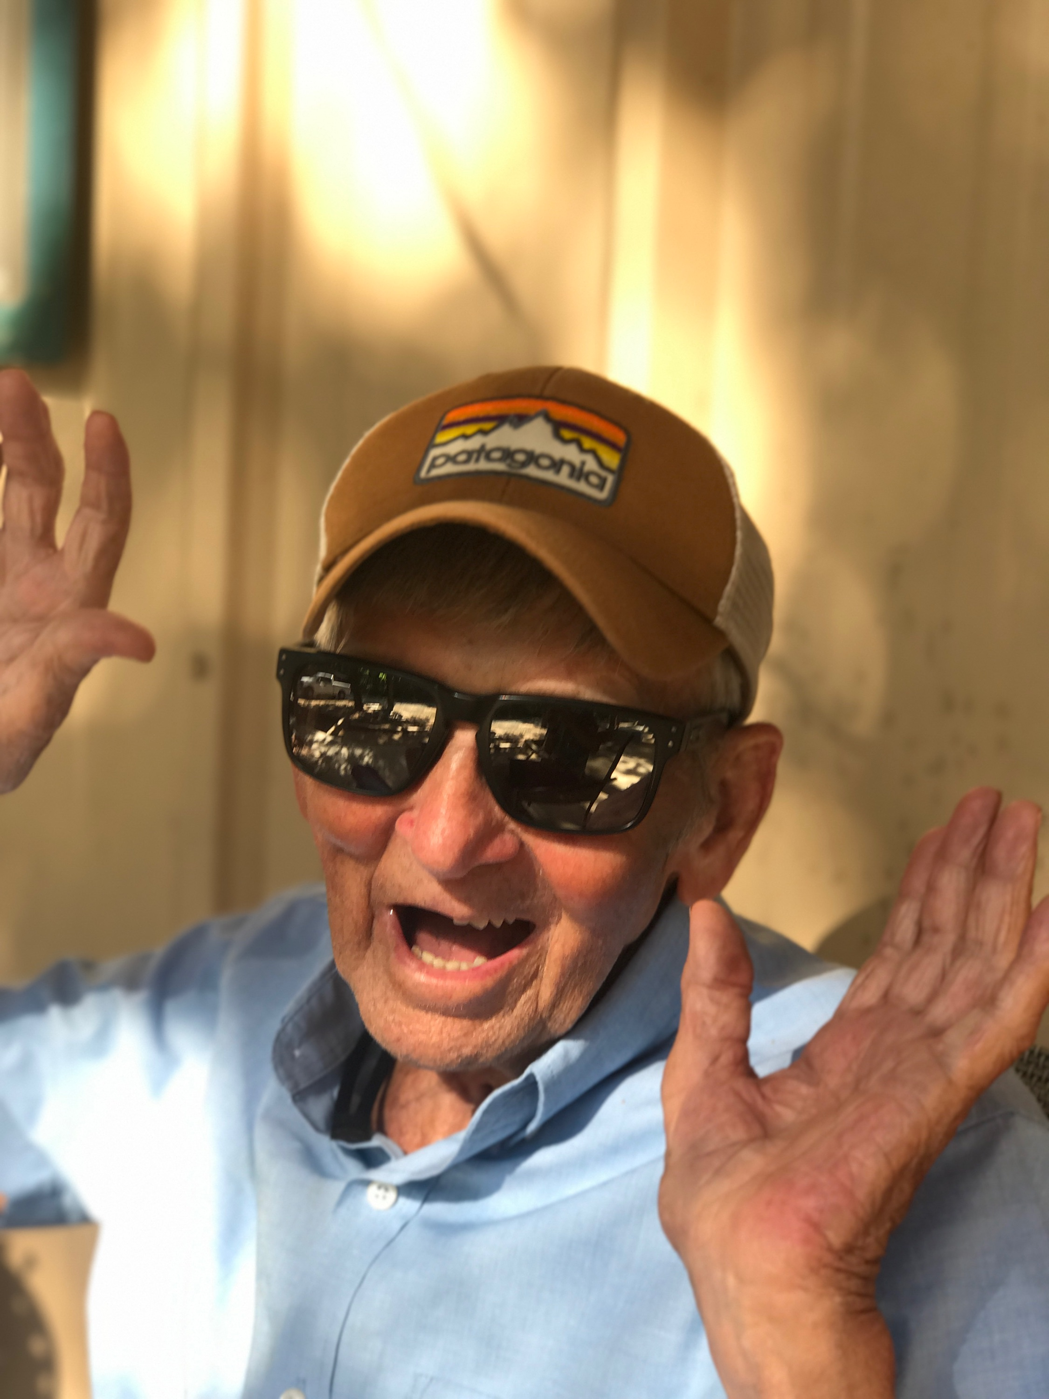  Registration Jan. 7-April 5 Tee off April 8 at 9 a.m. Lunch at 1 p.m. 4 man teams-$400 team/ $100 a man

